 Boyne Brother’s Golf Challenge  19th & 20th April 2013  Co. Meath’s Unique 3 Brothers Golf Competition | 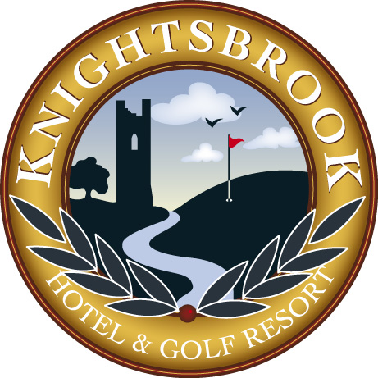  Knightsbrook Hotel  Spa & Golf Resort  Trim, Co Meath

REGISTRATION FORM

 | Brother 1 | Brother 2 | Brother 3
NAME:
ADDRESS:

EMAIL:
PHONE:

Package Type | Details | Price | Quantity | Total
3 Night Golfer Package | 3 Nights Bed & Full Irish Breakfast  2 Days Competition Golf  1 Gala BBQ Ticket  Complimentary Team Goody Bag | €650 per team |  | €
2 Night Golfer Package | 2 Nights Bed & Full Irish Breakfast  2 Days Competition Golf  1 Gala BBQ Ticket  Complimentary Team Goody Bag | €500 per team |  | €
1 Night Golfer Package | 1 Nights Bed & Full Irish Breakfast  2 Days Competition Golf  1 Gala BBQ Ticket  Complimentary Team Goody Bag | €350 per team
Non - Resident Package | 2 Days Competition Golf  1 Gala BBQ Ticket  Complimentary Team Goody Bag | €250  per team |  | €
Practice Round | Preferred Tee Times
Thursday 18th April 2013 |  | Free |  | €
 | TOTAL AMOUNT DUE |  |  | €

A BOOKING DEPOSIT OF €100 PER TEAM IS REQUIRED
AT TIME OF BOOKING
PLEASE SUBMIT TO GAVIN HUNT, DIRECTOR OF GOLF, KNIGHTSBROOK GOLF CLUB, TRIM, CO MEATH
TELEPHONE: 046 9482100 / 087 7585346 EMAIL:ghunt@knightsbrook.com
Tee Times For Practice Day Will Be Allocated On First Come First Served Basis

